*SAMSUNG mobile*

SAMSUNG S22 ULTRA

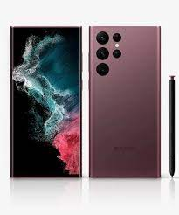

Samsung Galaxy S22 Ultra 5G ; **Size, 6.8 inches, 114.7 cm2** (~90.2% screen-to-body ratio) ; Resolution, 1440 x 3088 pixels, 19.3:9 ratio (~500 ppi density).

**PRICE /** 424,999.00 **PRK**